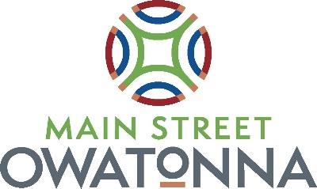

Downtown Thursday 2024
Sponsorship Form

Please return the completed form along with payment. We accept cash, check or credit card. Email to
Lisa Cochran at lcochran@owatonna.org, or mail to:
Lisa Cochran-Owatonna Area Chamber of Commerce & Tourism, 120 S. Oak Ave., Owatonna, MN 55060.

Your Business and Contact Information:

Name (First and Last):

Company Name:
Mailing Address:
City: State:
Zip:

Email Address: Primary Phone #:

What level of sponsorship are you generously giving for Main Street Owatonna – Downtown Thursdays?
Headline Sponsor $6,000 Jive Junction $3,000 Cedar Ave Stardom $1000 Activity Avenue $500
Who will be attending the event to represent your business? ___________________________________________
Which of the Downtown Thursday Event Days would you like to have a vendor spot? As a sponsor, you get a
vendor spot each month at no charge.
June 6 July 11 August 1 September 5

What is the nature of your business?

________________________________________________________________________________________________
Does your booth require electricity? If yes, describe the type/amount of electricity you will need:

What is your booth size? 10’ X 10’ Tent 10’ X 20’ Tent Truck or Trailer Area (size)_________

A confirmation email will be sent once paperwork and payment have been received at the Chamber Office. Included in the email will be our Vendor Guide which has additional details regarding Downtown Thursdays. The Friday before each event, you will receive a map that lists locations of all the businesses, food vendors, street vendors, and entertainment along with the script for introducing acts on the stages, if applicable. It will also include any last-minute updates. Depending on the level of sponsorship, you will be contacted to shoot a promo video.

___________________________________________________ ______________________
Signature Date

