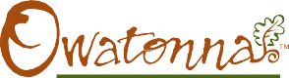
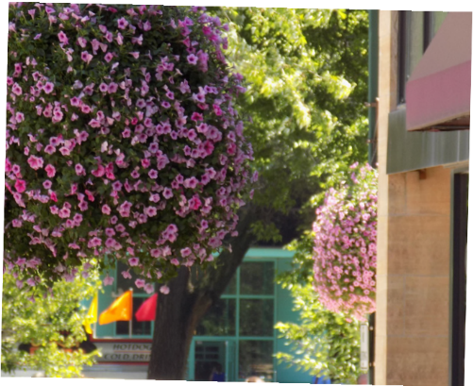
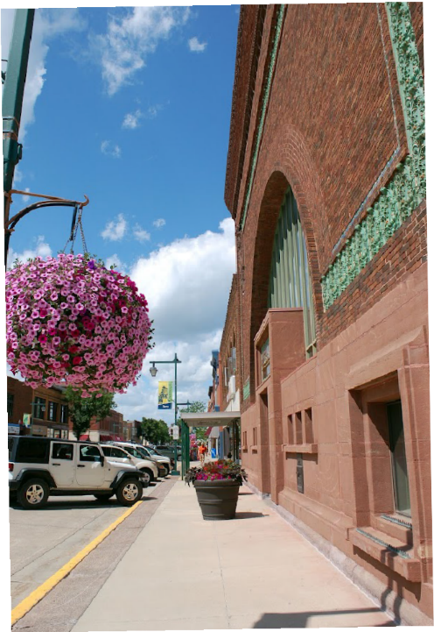
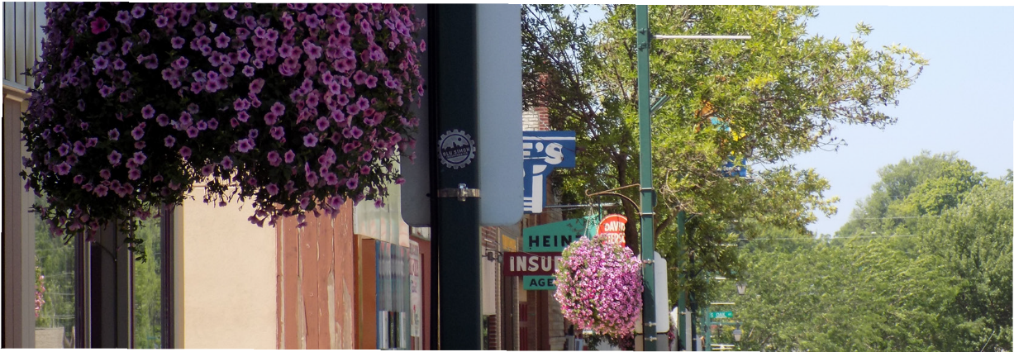
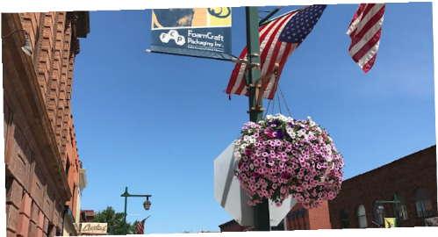

PLEASE HELP SUPPORT OUR FLOWER BASKET PROGRAM
FLOWER BASKETS
owatonna area chamber of commerce & tourism
owatonna.org

100% of your donation goes to flowers! The Flower Basket committee needs YOUR FINANCIAL SUPPORT to continue our hanging flower basket program for 2023.

Since 2004, the hanging flower baskets have become an Owatonna Landmark! They welcome everyone to Owatonna.

- The cost to plant and maintain a single basket for a season is over $125.
- We are asking for your financial support to help beautify Owatonna! Please fill out the contribution form below indicating your support and return to the Owatonna Chamber
Foundation. Your sponsorship is tax deductible and helps to make Owatonna a beautiful place to live, work & play!

- Our hanging flower basket program is funded ONLY through individual and business contributions! All donations large and small are appreciated.
- Giving baskets for gifts and memorials is a great idea! Questions? Contact Lisa Cochran at: lcochran@owatonna.org
or call 507-451-7970.
THANK YOU!

SUPPORT FLOWER BASKETS! 2023 Hanging Flower Basket Program Contribution Form (Please Print)

5 Baskets - $600 Donation
3 Baskets - $375 Donation
2 Baskets - $250 Donation
1 Basket - $125 Donation
Other Amount - $______

Sponsor Name: (Optional) In Honor/Memory of: ___________________________ Address: (Work Y/N?) _________________________________
Comments/Interested in Volunteering?_____________________

Donations are tax deductible if checks are made payable to: Owatonna Chamber Foundation- Flower Basket Program THANK YOU!

SPONSOR
AREA CHAMBER OF COMMERCE & TOURISM
320 Hoffman Drive, Owatonna, MN 55060 | 507.451.7970 • 800.423.6466 • F: 507.451.7972
oacct@owatonna.org • www.owatonna.org | Hours M-F: 8am-5pm | Follow us on: |

