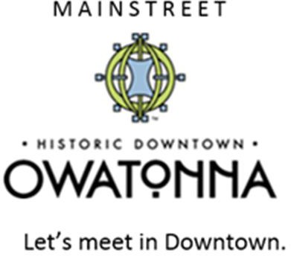
2023 Sponsor Application.

Please return completed form by emailing Lisa Cochran @ lcochran@owatonna.org, or mail to:
Lisa Cochran-Owatonna Area Chamber of Commerce & Tourism, 320 Hoffman Dr., Owatonna, MN 55060.

First Priority to Historic District Commercial Businesses

Your Business and Contact Information:
Name (First and Last):

Company Name:

Mailing Address:
City: State:
Zip:

Email Address: Primary Phone #:

Who will be attending the event to represent your business? ______________________________________________

What level of sponsorship are you applying for?
Headline Sponsor $8,000 Market Sponsor $3,000 Bands & Music Fans $1000 __Partnership $500
Which of the Downtown Thursday Event Days are you available to attend? (Please check all that apply):
June 2 July 7 August 4 September 8
What is your category of business? Do you want to vend products at Downtown Thursday?

Please provide a list and photos of products you intend to be approved to vend at Downtown Thursday:

Does your booth require electricity? If yes, describe the amount of electricity you will need:

What is your booth size? 10’ X 10’ Tent Area 10’ X 20’ Tent Area Truck or Trailer Area
Any other Information that we should know about your business:

