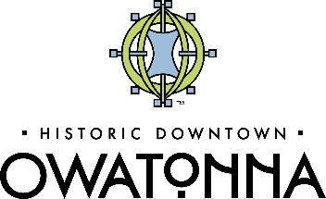
2023 Downtown Thursdays
Free outdoor summer concert series showcasing local, regional, and national bands, local food, beverages and artisans to welcome families, employees, visitors, & residents into the heart of Owatonna - revitalizing our downtown and enriching our community. This 4 time, event is an after- work, family-friendly social gathering that attracts thousands of attendees annually with its music and vendors. This event provides sponsors the opportunity to engage with a diverse group of individuals in Downtown Owatonna.

DOWNTOWN THURSDAYS
JUNE 1 JULY 6 AUGUST 3 SEPTEMBER 7
Downtown Owatonna Central Park & North Cedar Ave

Audience (2022): 2000 est. attendees per event
Expect (2023) 3000-4000 per event
Potential estimated reach of 12,000-16,000
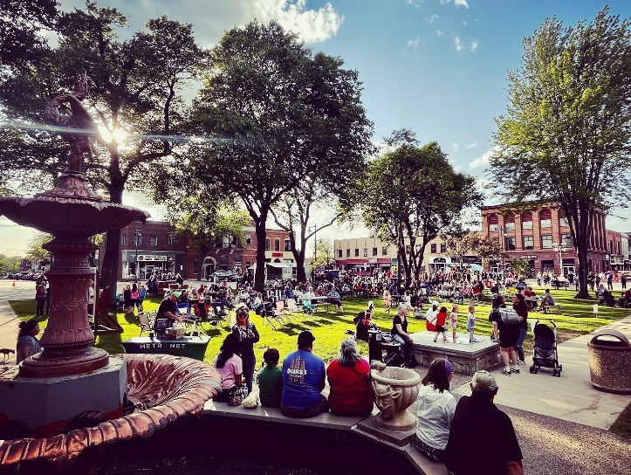

2023 HEADLINE SPONSORSHIP: $8,000 (1 Available)

- Category exclusivity for all 4 events
- VIP Opportunities: Seating and 10 drink tickets for staff or guests for all 4 events
- A larger impact of brand visibility through an exclusive
sponsorship with a large banner displayed on stage for each event and opportunity to introduce headlining act each event
- Prominent logo on event signage, Mainstreet website
- Prominent logo inclusion on posters, fliers, and social media
- Prominent recognition in print and radio ads
- Booth at all 4 events
- Selfie Station with logo backdrop and custom frame options.
- MARKET SPONSOR: $3,000 (limited available)
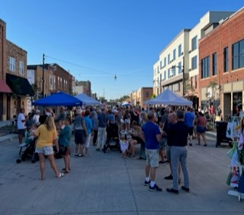
- Logo on all event signage and Mainstreet Website
- Logo on all marketing posters, fliers and social media
- Booth at all 4 events
- Opportunity to introduce act on Showmobile stage each event
- Recognition in print and radio ads
2023 BANDS & FANS SPONSOR: $1,000 (unlimited)
l. Live thank you from stage
- Logo on event banner and signage
- Booth at each event
- Recognition in radio ads and social media
2023 PARTNERSHIP SPONSOR: $500 (unlimited)
- Live thank you from stage
- Booth at all 4 event
- Logo on signage displayed at event

