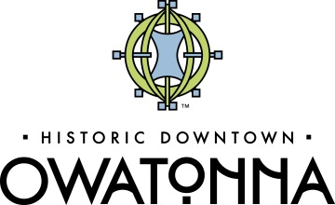
Official 2018 Retail Challenge Entry Form
Contact Information
Contact Person
Name of Business Contact
Address
City, State, Zip Code
E-mail Address
Phone Number

Retail Business Concept
Please Select which option best describes your retail business concept.
Yes | New Retail Business
Yes | Second or third retail business from an existing location in another town
Yes | Significant expansion of a current downtown Owatonna business that includes an added business concept

Briefly describe your retail business concept.

What types of merchandise will be sold in your retail store?

Describe and define the market for this retail business.

How will your business enhance downtown Owatonna and the Owatonna community as a whole?

What resources and assets do you have and what resurces would be needed to develop this concept (personal financing, equipment, etc.)?

What are your qualifications to develop/expand this business?

Are there any similar businesses around already? If so, how is yours different?

Any other information that may really “sell” the committee on your concept?

I have read the competition rules, timeline and eligibility requirements, and I attest that all information included in this application and business concept is true and accurate. By submitting this application, you agree to the rules and regulation of this competition.

X
Signature Date

Please submit this application form by September 14, 2018 to:
Owatonna Area Chamber of Commerce
c/o Retail Challenge
320 Hoffman Drive
Owatonna, MN 55060

MainStreet Owatonna

